Microbial Control of Oceanic Carbon Flux: The Plot Thickens
FAROOQ AZAM 1998

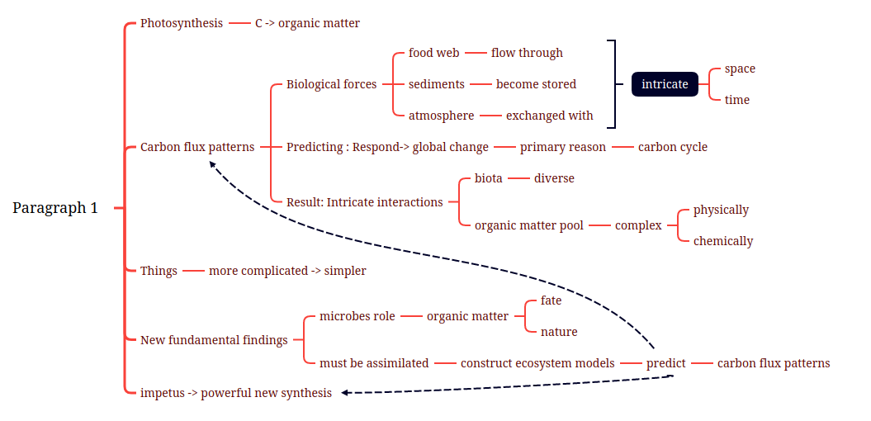
Photosynthesis fixes carbon into organic matter in the ocean. Biological forces then paint intricate flux patterns for carbon in ocean space and in time, as it flows through the food web, becomes stored in the sediments and exchanged with the atmosphere. Predicting how these carbon flux patterns might respond to global change (or to human manipulation) is a primary reason for learning more about the workings of the ocean's carbon cycle. The flux patterns are a result of intricate interactions of a diverse biota with a physically and chemically complex pool of organic matter. It now seems that things will get even more complicated before they get simpler. New fundamental findings on the roles of microbes in the fate of organic matter and, recently, on the nature of the organic matter itself (1-4) must be properly assimilated before we can hope to construct ecosystem models to predict the patterns of carbon flux. This impetus could lead to a powerful new synthesis.

Photosynthesis fixes carbon into organic matter in the ocean.
Photosynthesis fixes carbon into organic matter in the ocean.
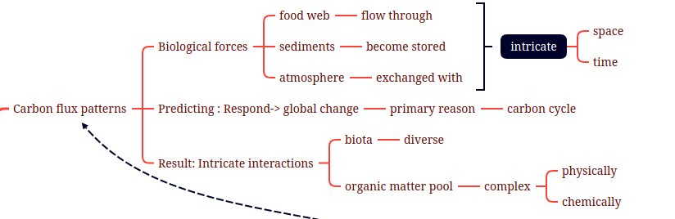
Biological forces then paint intricate carbon flux patterns for carbon in ocean space and in time, as it flows through the food web, becomes stored in the sediments and is exchanged with atmosphere.
Biological forces then paint intricate flux patterns for carbon in ocean space and in time, as it flows through the food web, becomes stored in the sediments and exchanged with the atmosphere.

Predicting how these carbon flux patterns might respond to global change (or to human manipulation) is the a primary reason for studying learning more about the workings of the ocean’s carbon cycle.
Predicting how these carbon flux patterns might respond to global change (or to human manipulation) is a primary reason for learning more about the workings of the ocean's carbon cycle.

The flux patterns are a result of the intricate interactions of a diverse biota with a physically and chemically complex pool of organic matter.
The flux patterns are a result of intricate interactions of a diverse biota with a physically and chemically complex pool of organic matter.

It now seems that things will get even more complicated before they can get simpler.
It now seems that things will get even more complicated before they get simpler.
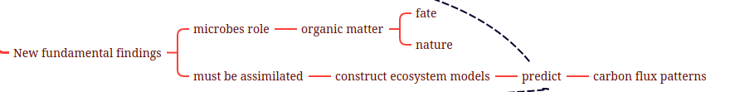
New fundamental findings on the roles of microbes in the fate and nature of organic matter must be assimilated before constructing ecosystem models to predict carbon flux patterns.
New fundamental findings on the roles of microbes in the fate of organic matter and, recently, on the nature of the organic matter itself (1-4) must be properly assimilated before we can hope to construct ecosystem models to predict the patterns of carbon flux.
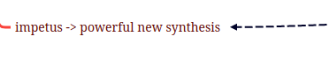
This can be an impetus for a powerful new synthesis.
This impetus could lead to a powerful new synthesis
What biological forces act on photosynthetically produced organic matter in the ocean? Historically, the paradigm has been that essentially all primary production stays within the particle phase (5), it is eaten by herbivores, and the fate of carbon is determined by the “grazing food chain” (see the diagram in the figure below). Little dissolved organic matter is spilled for bacteria to use. It had, therefore, been implicitly assumed to be safe to ignore bacteria, protozoa, and viruses in studying the fate of organic matter—they were too sparse and not active enough (5). This is now changed (5-8): Major fluxes of organic matter, often eclipsing the grazing food chain in quantity, move via dissolved organic matter into bacteria and the “microbial loop” (7, 8) (figure below). Previous methods had missed >99% of microorganisms and had grossly underestimated their metabolism. Now we know from extensive field studies that in most of the ocean, organic matter flux into bacteria is a major pathway; one-half of oceanic primary production on average is channeled via bacteria into the microbial loop (7, 8)—a major biological force in the ocean.
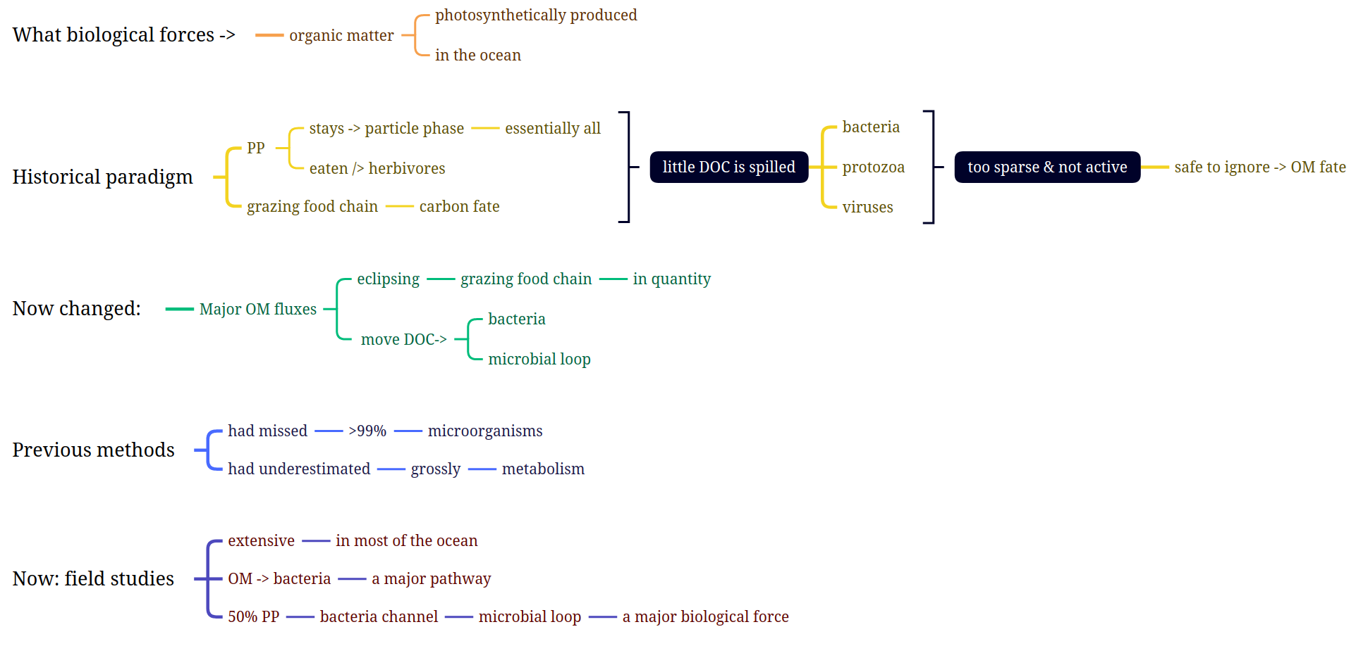
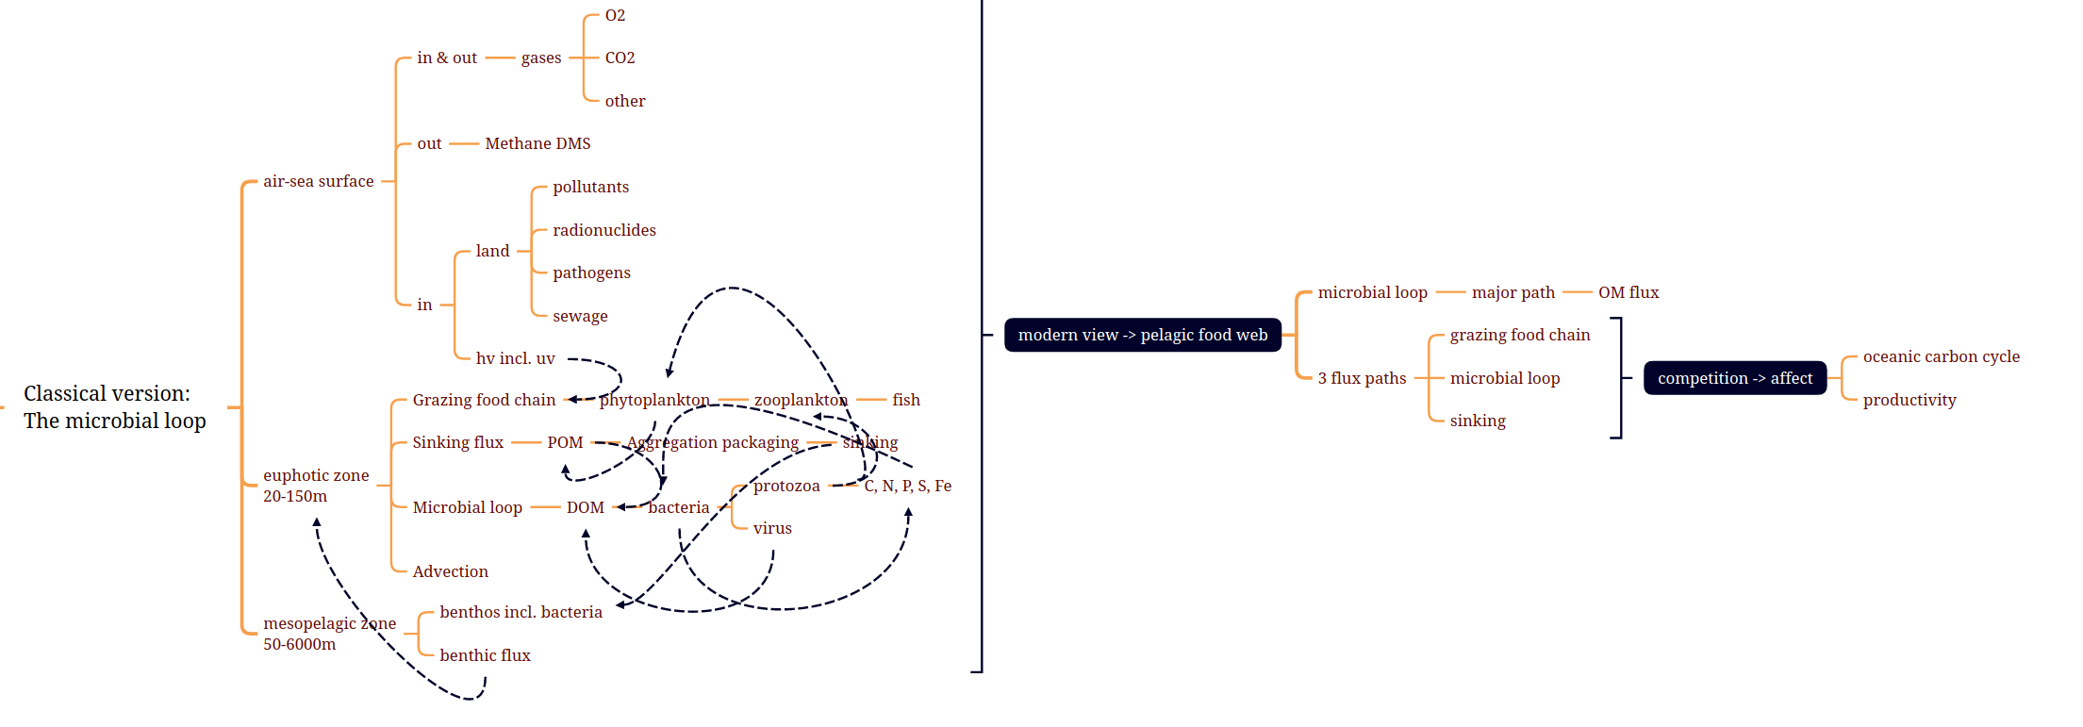
The microbial loop: classical version.
Modern view of the pelagic food web, emphasizing the microbial loop as a major path for organic matter flux. Competition between the three main flux paths—grazing food chain, microbial loop, and sinking—significantly affects oceanic carbon cycle and productivity. DOM, dissolved organic matter; DMS, dimethylsulfide.
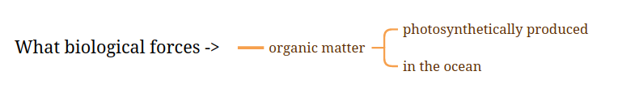
What biological forces act on the photosynthetically produced organic matter in the ocean?
What biological forces act on photosynthetically produced organic matter in the ocean?
What biological forces act on photosynthetically produced organic matter in the ocean?
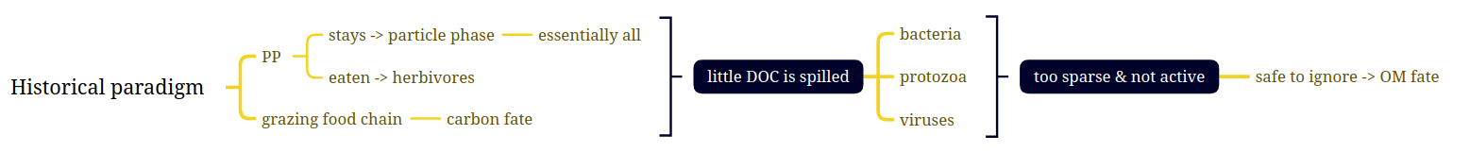
Historically, a widely accepted paradigm suggests that primary production essentially all stays in the phase of particle and is eaten by herbivores and the fate of carbon is determined by the grazing food chain.
Historically, the paradigm has been that essentially all primary production stays within the particle phase (5), it is eaten by herbivores, and the fate of carbon is determined by the “grazing food chain” (see the diagram in the figure below).
Historically, the paradigm has been that essentially all primary production stays within the particle phase, it is eaten by herbivores and the fate of carbon is determined by the grazing food chain.
therefore, little dissolved organic carbon is spilled for bacteria to use.
Little dissolved organic matter is spilled for bacteria to use.
this implicitly suggests that it is safe to ignore the role of bacteria, protozoa and virus in the fate of organic matter, they are too sparse and not active enough.
It had, therefore, been implicitly assumed to be safe to ignore bacteria, protozoa, and viruses in studying the fate of organic matter—they were too sparse and not active enough (5).
It had, therefore, been implicitly assumed to be safe to ignore bacteria, protozoa and viruses in studying the fate of organic matter -- they were too sparse and not active enough.
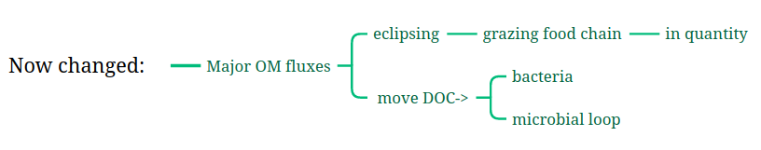
Now things are changed: Major fluxes of organic matter, eclipsing the grazing food chain in quantity, move into bacteria and microbial loop via dissolved organic carbon.
This is now changed (5-8): Major fluxes of organic matter, often eclipsing the grazing food chain in quantity, move via dissolved organic matter into bacteria and the “microbial loop” (7, 8) (figure below).
This is now changed: major fluxes of organic matter, often eclipsing the grazing food chain in quantity, move via dissolved organic matter into bacteria and the ‘microbial loop’.
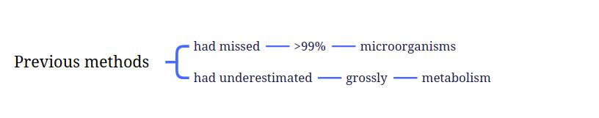
Previous methods had missed >99% of microorganisms and had grossly underestimated their metabolism.
Previous methods had missed >99% of microorganisms and had grossly underestimated their metabolism.
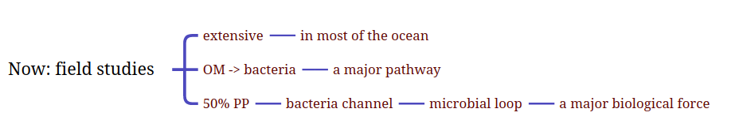
Now extensive field studies in most of the ocean has found that transport of organic matter via bacteria is a major pathway.
Now we know from extensive field studies that in most of the ocean, organic matter flux into bacteria is a major pathway;
Now we know from extensive field studies that in most of the ocean, organic matter flux into bacteria is a major pathway;
One-half of primary production is channeled via bacteria in the microbial loop, which is a major biological force.
one-half of oceanic primary production on average is channeled via bacteria into the microbial loop (7, 8)—a major biological force in the ocean.
One-half of oceanic primary production on average is channeled via bacteria into the microbial loop -- a major biological force in the ocean.

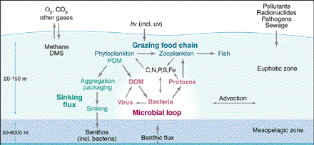
The microbial loop: classical version.
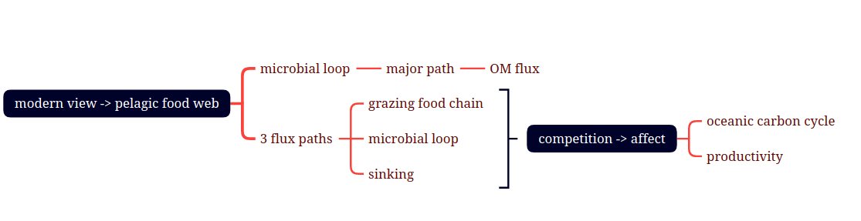
Modern view of pelagic food web emphasizes that the microbial loop is a major path for organic matter flux.
Modern view of the pelagic food web, emphasizing the microbial loop as a major path for organic matter flux.
Modern view of the pelagic food web, emphasizing the microbial loop as a major path for organic matter flux.
Competition among three flux paths, grazing food chain, microbial loop and sinking, significantly affect oceanic carbon cycle and productivity.
Competition between the three main flux paths—grazing food chain, microbial loop, and sinking—significantly affects oceanic carbon cycle and productivity.
Competition among the three main flux paths—grazing food chain, microbial loop and sinking—significantly affects oceanic carbon cycle and productivity.

Ocean basin-scale biogeochemical studies now routinely quantify organic matter fluxes into bacteria in conjunction with other major flux pathways: grazing food chain, sinking flux, and dissolved organic matter “storage.” The fraction of primary production used by bacteria (Fb) is highly variable over various time and space scales (7-10). The magnitudes and variability of the fluxes are large enough to cause variability in flux partitioning between competing pathways (see figure below)—the microbial loop, the grazing food chain, sinking fluxes, and storage of dissolved organic matter (8, 9). Fish production in the eastern Mediterranean was diminished by a dominant microbial loop (Fb = 0.85) (11). In an earlier study (12), the richness of the fishery in coastal Newfoundland was ascribed to uncoupling of bacteria from primary production during the spring bloom. These are tantalizing but rare success stories where descriptive studies lead to interesting insights into the bacterial control of organic matter fluxes and ecosystem dynamics.

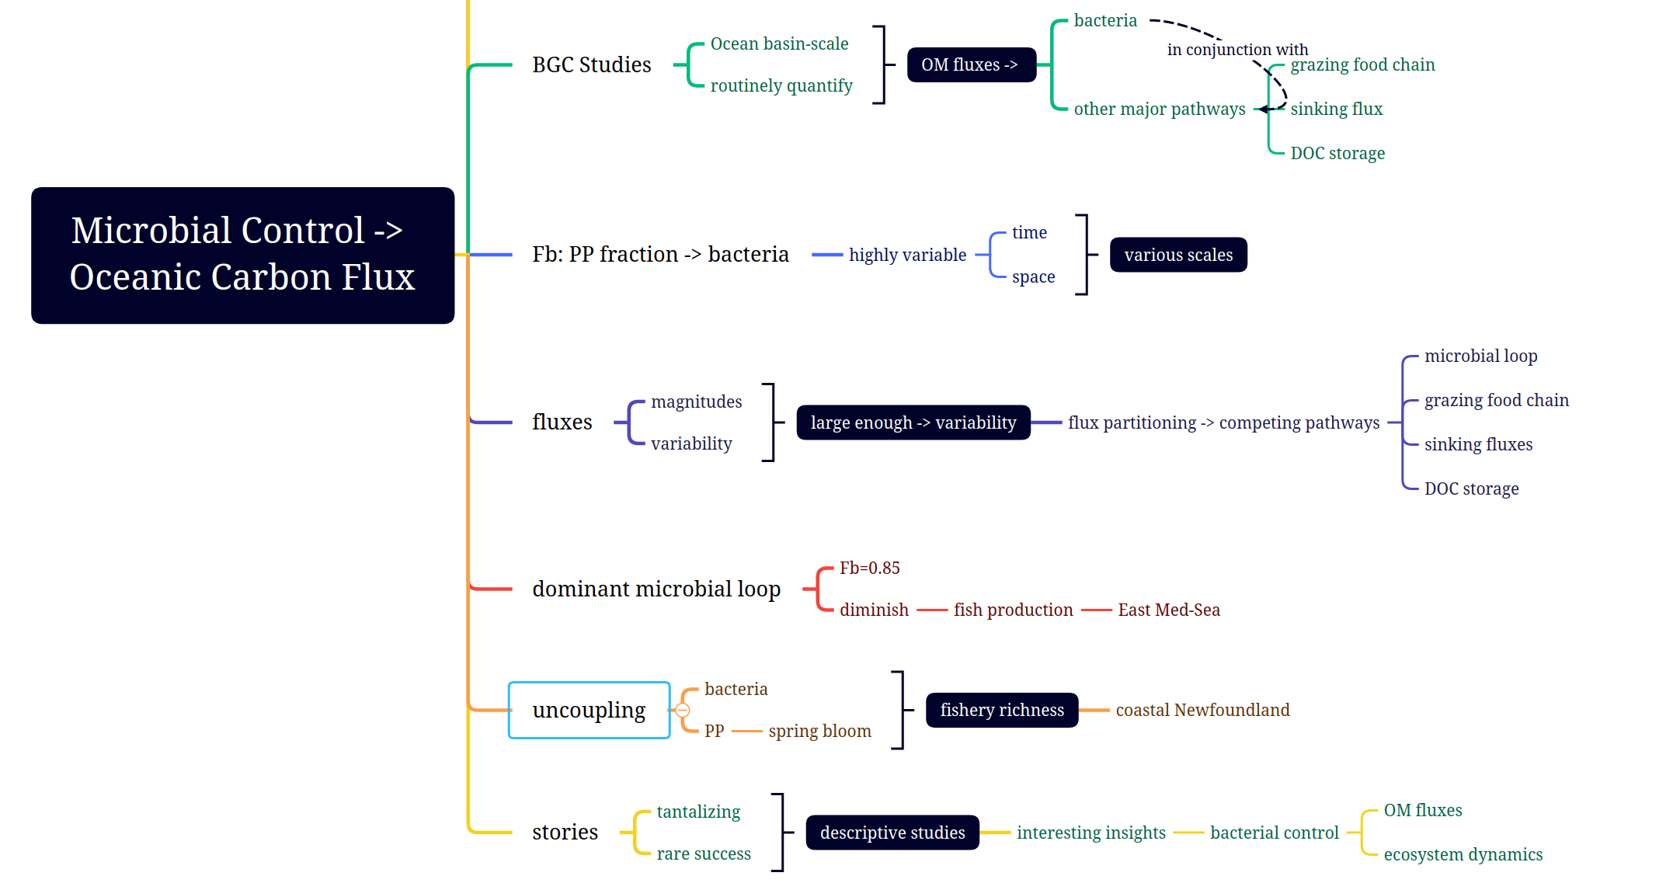

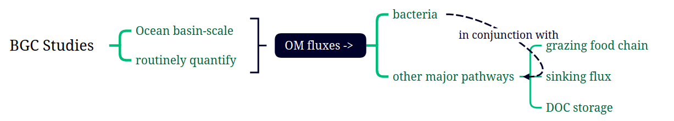
Recent ocean basin-scale biogeochemical studies routinely quantify organic matter fluxes into bacteria in conjunction with other major pathways including grazing food chain, sinking flux and dissolved organic matter storage.
Ocean basin-scale biogeochemical studies now routinely quantify organic matter fluxes into bacteria in conjunction with other major flux pathways: grazing food chain, sinking flux, and dissolved organic matter “storage.”
Ocean basin-scale biogeochemical studies now routinely quantify organic matter fluxes into bacteria in conjunction with other major flux pathways: grazing food chain, sinking flux and dissolved organic matter storage.
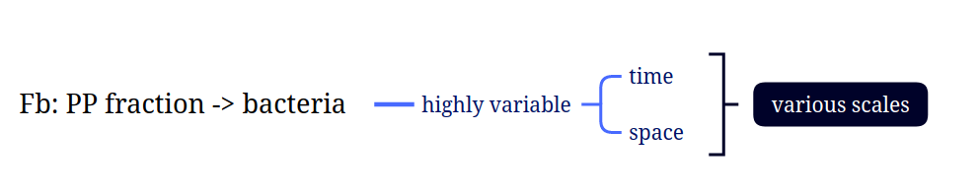
The fraction of primary production into bacteria (Fb) is highly variable over various time and space scales.
The fraction of primary production used by bacteria (Fb) is highly variable over various time and space scales (7-10).
The fraction of primary production used by bacteria (Fb) is highly variable over various time and space scales.
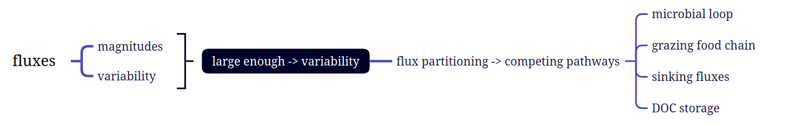
The magnitudes and variability are large enough to influence the variability of flux partitioning between these competing pathways including microbial loop, grazing food chain, sinking fluxes and DOC storage.
The magnitudes and variability of the fluxes are large enough to cause variability in flux partitioning between competing pathways (see figure below)—the microbial loop, the grazing food chain, sinking fluxes, and storage of dissolved organic matter (8, 9).
The magnitudes and variability of the fluxes are large enough to cause variability in flux partitioning between competing pathways – the microbial loop, the grazing food chain, sinking fluxes and storage of dissolved organic matter.

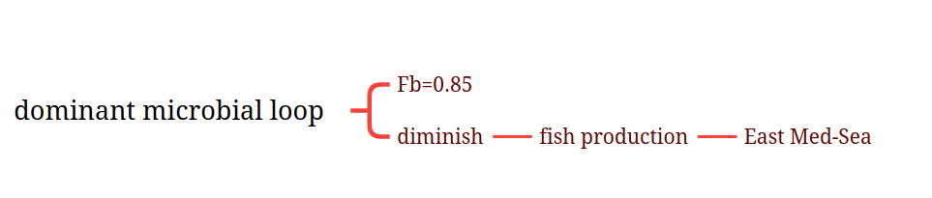
A study in the East Med-Sea showed that fish production was diminished by the dominant microbial loop (Fb=0.85).
Fish production in the eastern Mediterranean was diminished by a dominant microbial loop (Fb = 0.85) (11).
Fish production in the eastern Mediterranean was diminished by a dominant microbial loop (Fb=0.85).
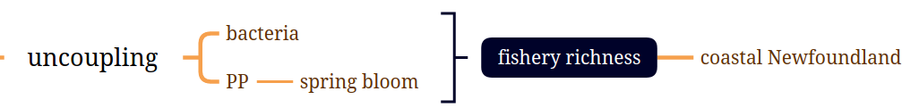
A few studies found that fishery richness in the coastal Newfoundland was ascribed to the uncoupling between bacteria and primary production during spring bloom.
In an earlier study (12), the richness of the fishery in coastal Newfoundland was ascribed to uncoupling of bacteria from primary production during the spring bloom.
In an earlier study, the richness of the fishery in coastal Newfoundland was ascribed to uncoupling of bacteria from primary production during the spring bloom.
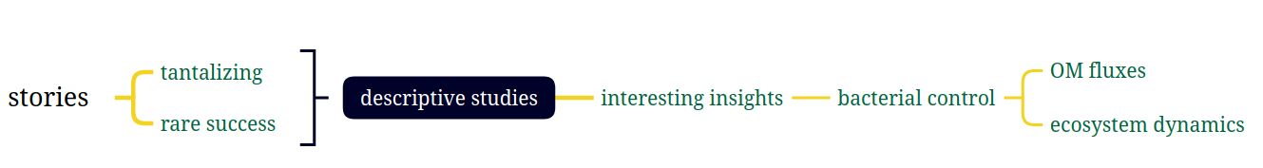
These tantalizing and rare success stories show descriptive studies have interesting insights in the bacterial control of organic matter fluxes and ecosystem dynamics.
These are tantalizing but rare success stories where descriptive studies lead to interesting insights into the bacterial control of organic matter fluxes and ecosystem dynamics.
These are tantalizing but rare success stories where descriptive studies lead to interesting insights into the bacteria control of organic matter fluxes and ecosystem dynamics.

However, we lack a conceptual framework to predict variation in organic matter flux into bacteria and how it fits into the overall oceanic flux picture (for example, how the flux partitioning will respond to global change). This requires elucidating the causes and mechanisms of variability of organic matter flux into bacteria. How do bacteria interact with organic matter, and what regulates the flux of organic matter into them?
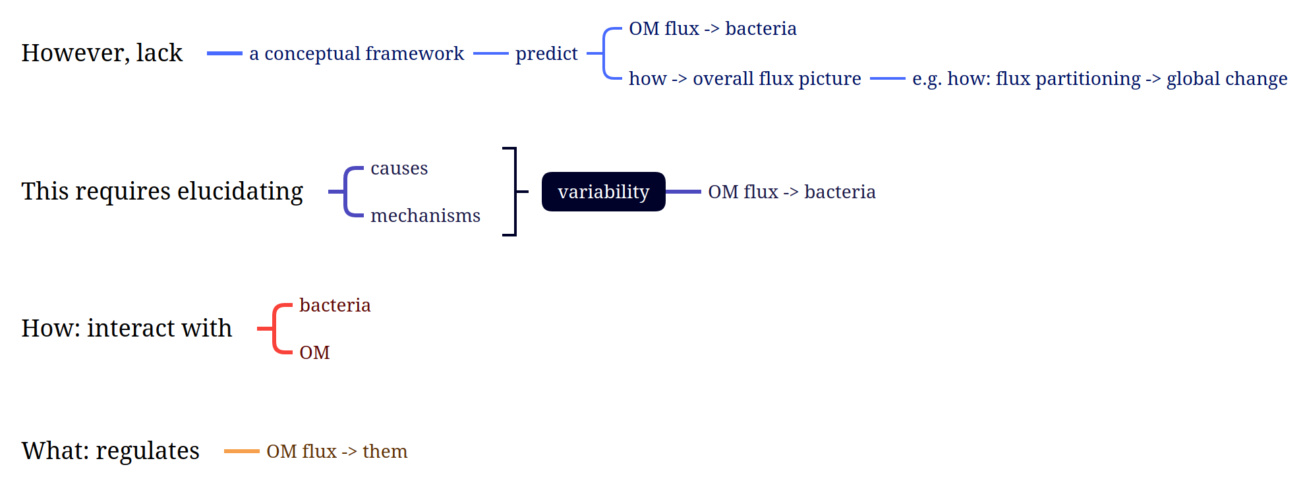

However, we lack a conceptual framework to predict the flux of organic matter into bacteria and how is the overall oceanic flux picture like, for example, how does flux partitioning response to global change?
However, we lack a conceptual framework to predict variation in organic matter flux into bacteria and how it fits into the overall oceanic flux picture (for example, how the flux partitioning will respond to global change).
However, we lack a conceptual framework to predict variation in organic matter flux into bacteria and how it fits into the overall oceanic flux picture (for example, how the flux partitioning will respond to global change.)
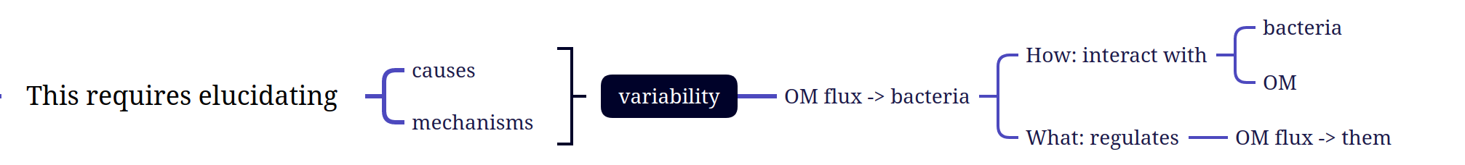
This requires elucidating causes and mechanisms of variability of organic matter flux into bacteria.
This requires elucidating the causes and mechanisms of variability of organic matter flux into bacteria.
This requires elucidating the causes and mechanisms of variability of organic matter flux into bacteria.
How bacteria interact with organic matter and what regulates organic matter flux into them.
How do bacteria interact with organic matter, and what regulates the flux of organic matter into them?
How do bacteria interact with organic matter and, what regulates the flux of organic matter into them?

It is generally thought that pelagic bacteria passively receive dissolved organic matter leaking from the grazing food chain and diffused homogeneously. However, recent studies on the complex nature of the organic matter field (1-4, 13) and behavioral strategies of bacteria (14) have suggested (2) that bacteria do not use only preformed dissolved organic matter; they also attack all organic matter, even live organisms, thus liberating dissolved organic matter. Hence, bacterial attack can profoundly modify the biogeochemical behavior of organic matter in ways not inferred from measuring cumulative organic matter fluxes into bacteria. Recognition of such “modification interactions” could add important new variables in biogeochemical models.
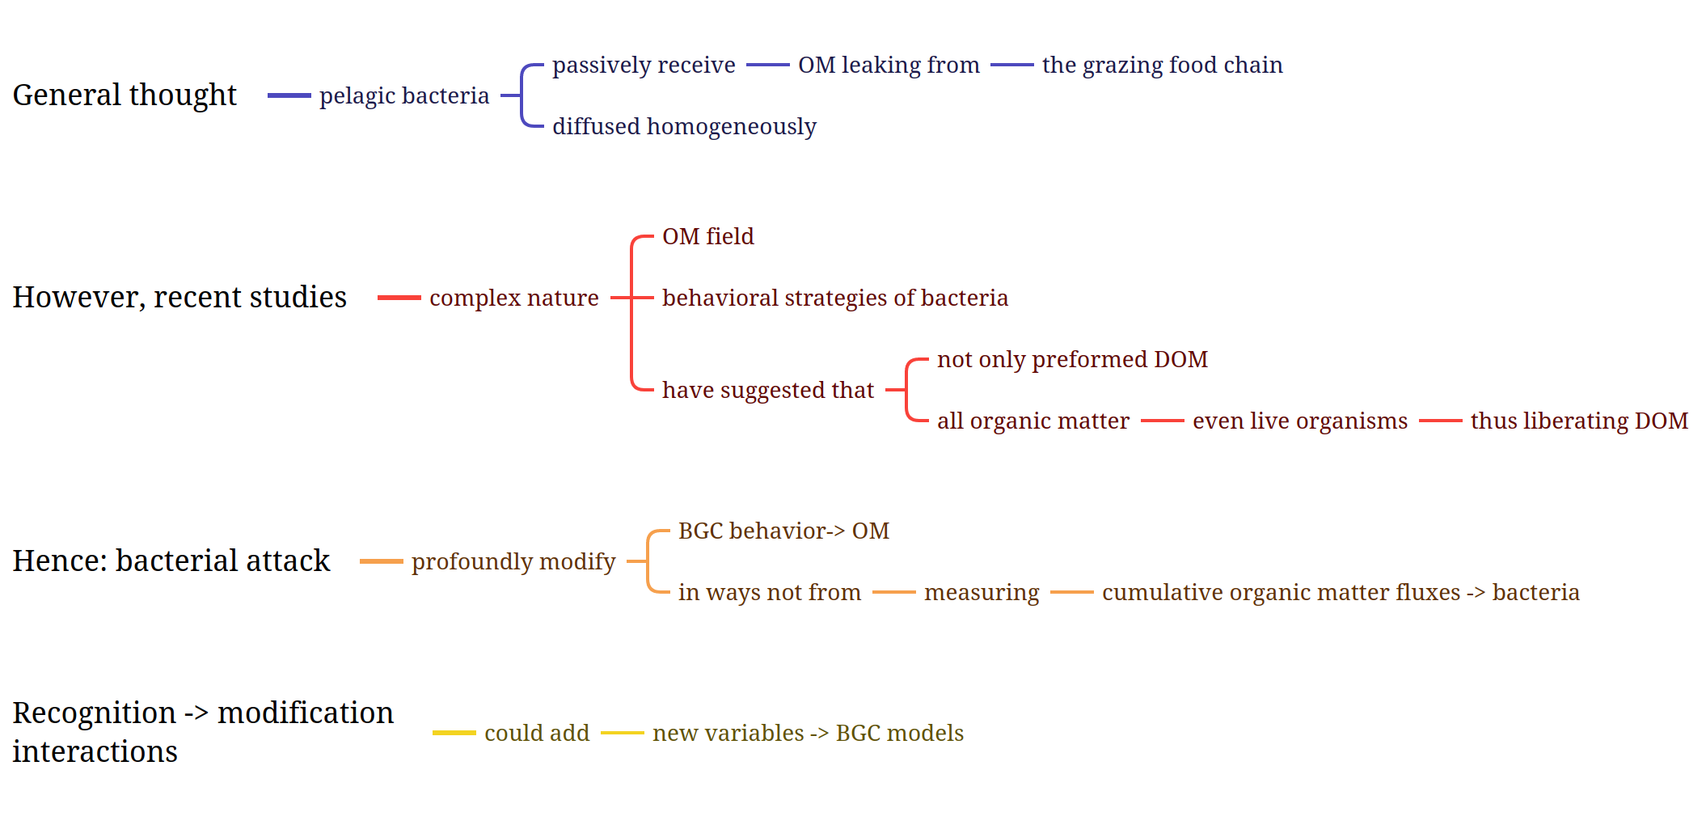
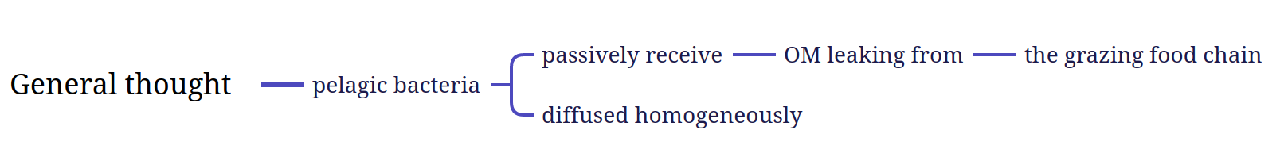
It is generally thought that pelagic bacteria passively receive organic matter leaking from the grazing food chain and diffused homogeneously.
It is generally thought that pelagic bacteria passively receive dissolved organic matter leaking from the grazing food chain and diffused homogeneously.
It is generally thought that pelagic bacteria passively receive organic matter leaking from the grazing food chain and diffused homogeneously.
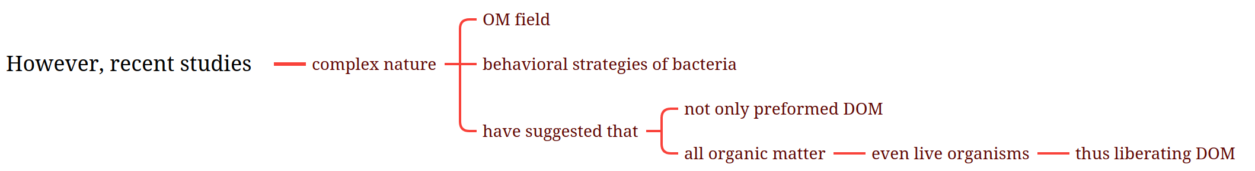
However, recent studies in the complex nature of organic matter field and behavioral strategies of bacteria have suggested that not only preformed dissolved organic matter are used but all organic matter even live organisms thus liberating dissolved organic matter.
However, recent studies on the complex nature of the organic matter field (1-4, 13) and behavioral strategies of bacteria (14) have suggested (2) that bacteria do not use only preformed dissolved organic matter; they also attack all organic matter, even live organisms, thus liberating dissolved organic matter.
However, recent studies on the complex nature of the organic matter field and behavioral strategies of bacteria have suggested that bacteria do not use only preformed dissolved organic matter; they also attack all organic matter, even live organisms, thus liberating dissolved organic matter.

Hence, bacterial attack can profoundly modify the biogeochemical behavior of organic matter in important ways not inferred from measuring cumulative organic matter fluxes into bacteria.
Hence, bacterial attack can profoundly modify the biogeochemical behavior of organic matter in ways not inferred from measuring cumulative organic matter fluxes into bacteria.
Hence, bacterial attack can profoundly modify the biogeochemical behavior of organic matter in ways not inferred from measuring cumulative organic matter fluxes into bacteria.

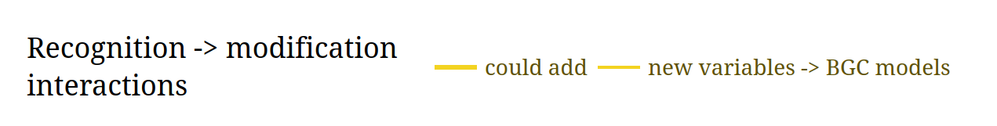
Recognition of the modification in the interactions could add new variables in the biogeochemical models.
Recognition of such “modification interactions” could add important new variables in biogeochemical models.
Recognition of such ‘modification interactions’ could add important new variables in biogeochemical models.

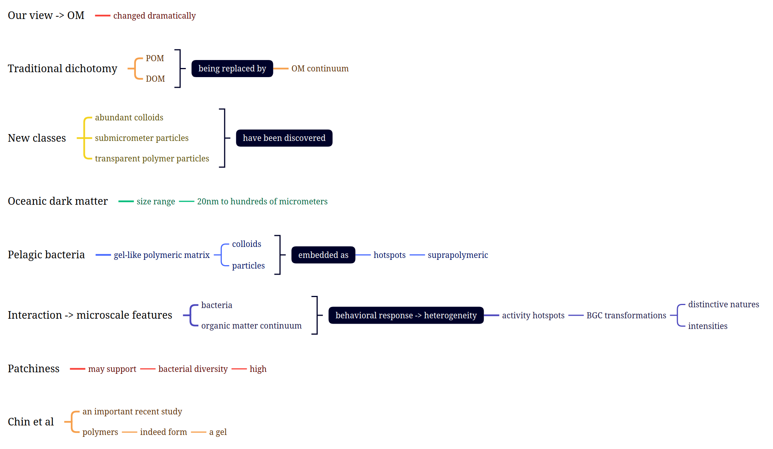
Our view of the organic matter in seawater has changed dramatically. The traditional dichotomy of particulate organic matter versus dissolved organic matter is being replaced by the concept of an organic matter continuum (2). Several new classes of abundant colloids, submicrometer particles, and transparent polymer particles have been discovered (1, 4, 13). This oceanic “dark matter” ranges in size from 20 nm to hundreds of micrometers. It has been proposed (2, 3) that pelagic bacteria experience a gel-like polymeric matrix with colloids and particles embedded as suprapolymeric “hotspots” (8) (see the lower part of the figure). The interaction of bacteria with the organic matter continuum, and their behavioral response to its heterogeneity, creates microscale features—activity hotspots—with distinctive natures and intensities of biogeochemical transformations. Patchiness may also support high bacterial diversity. An important recent study by Chin et al. (1) demonstrated that polymers in seawater indeed form a gel.

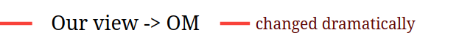
Our view of organic matter has changed dramatically.
Our view of the organic matter in seawater has changed dramatically.
Our view of the organic matter in seawater has changed dramatically.
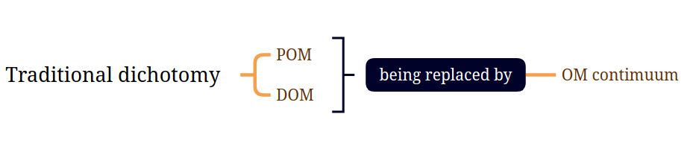
The traditional dichotomy of particulate organic matter and dissolved organic matter is being replaced by organic matter continuum.
The traditional dichotomy of particulate organic matter versus dissolved organic matter is being replaced by the concept of an organic matter continuum (2).
The traditional dichotomy of particulate organic matter versus dissolved organic matter is being replaced by the concept of an organic matter continuum.

Several new classes including abundant colloids, submicrometer particles and transparent polymer particles have been discovered.
Several new classes of abundant colloids, submicrometer particles, and transparent polymer particles have been discovered (1, 4, 13).
Several new classes of abundant colloids, submicrometer particles, and transparent polymer particles have been discovered.
Oceanic dark matter range in size from 20nm to hundreds of micrometers.
This oceanic “dark matter” ranges in size from 20 nm to hundreds of micrometers.
This oceanic ‘dark matter’ ranges in size from 20nm to hundreds of micrometers.
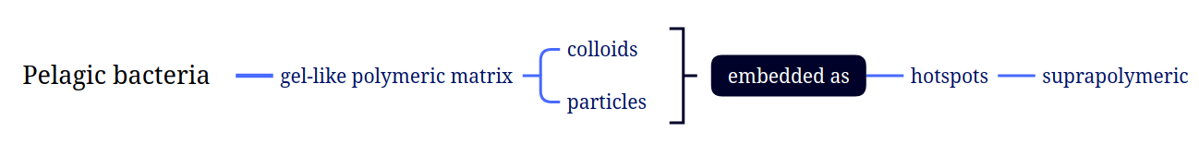
Pelagic bacteria is a gel-like polymeric matrix of colloids and particles embedded as suprapolymeric hotspots.
It has been proposed (2, 3) that pelagic bacteria experience a gel-like polymeric matrix with colloids and particles embedded as suprapolymeric “hotspots” (8)
It has been proposed that pelagic bacteria experience a gel-like polymeric matrix with colloids and suprapolymeric hotspots.
Interaction between bacteria and organic matter continuum is a behavioral response to the heterogeneity of these activity hotspots with biogeochemical transformations in distinctive natures and intensities which determines the microscale features.
The interaction of bacteria with the organic matter continuum, and their behavioral response to its heterogeneity, creates microscale features—activity hotspots—with distinctive natures and intensities of biogeochemical transformations.
The interaction of bacteria with the organic matter continuum and their behavioral response to its heterogeneity, creates microscale features-- activity hotspots-- with distinctive natures and intensities of biogeochemical transformations.

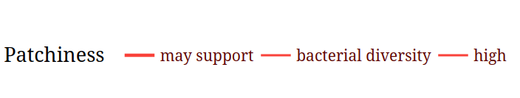
The patchiness may support high bacterial diversity.
Patchiness may also support high bacterial diversity.
Patchiness may also support high bacterial diversity.
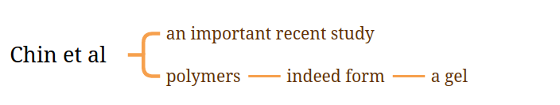
An important recent study from chin et al stated that polymers indeed form a gel.
An important recent study by Chin et al. (1) demonstrated that polymers in seawater indeed form a gel.
An important recent study by Chin et al demonstrated that polymers in seawater indeed form a gel.

Do bacteria respond to the structure of the organic matter field? Large bacterial populations can develop on hotspots—for example, marine snow, dead and even living algae—and in association with the “dark matter.” [In one study, 24 to 68% of bacteria were on transparent particles (13)]. Oceanic bacteria (14) exhibit sophisticated behavior—swimming speeds of hundreds of micrometers per second, unusual swimming (run reversals), and chemosensing. The organic matter field is dominantly polymeric and suprapolymeric, so most pelagic bacteria have a diverse repertoire of surface-bound enzymes (proteases, glucosidases, lipases, phosphatases, nucleases) to cause its hydrolysis (15). Small-scale variation of species composition can significantly change the distributions of enzyme activities (16). Pelagic bacteria also have multiphasic permeases for nutrient uptake (17), with nanomolar to millimolar half-saturation constants, suggesting their adaptations to life in a patchy environment. Considering the intimate contact of their “digestive system” with the organic matter gel, motile bacteria are the “ultimate swimming stomachs” (18). They cannot avoid interacting with and changing organic matter.
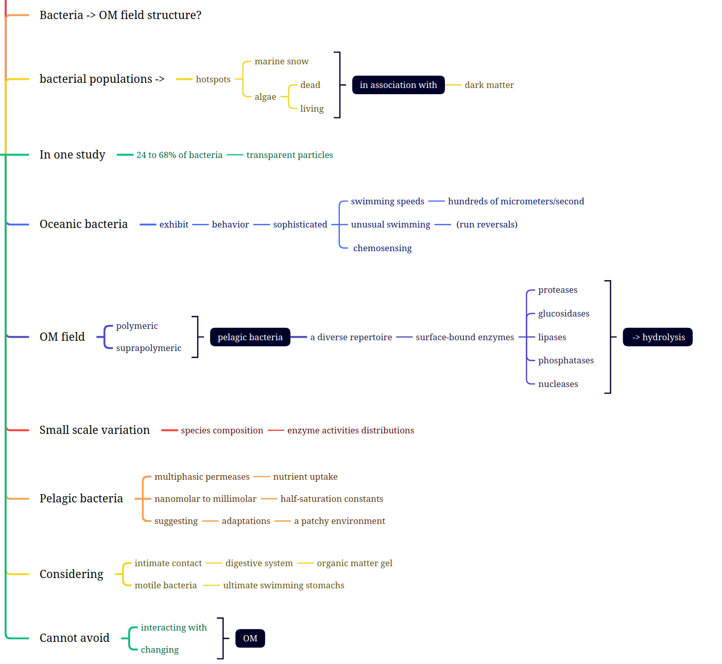
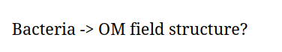
Do bacteria response to the structure of organic matter field?
Do bacteria respond to the structure of the organic matter field?
Do bacteria respond to the structure of the organic matter field?
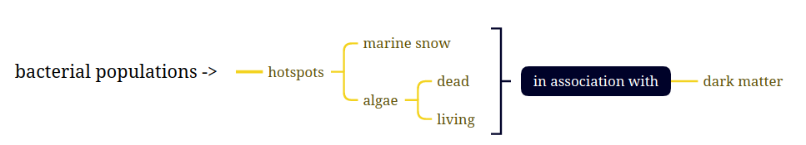
Large bacterial populations can attach to the hotspots, e.g. marine snow, dead and even living algae in association with the dark matter.
Large bacterial populations can develop on hotspots—for example, marine snow, dead and even living algae—and in association with the “dark matter.”
Large bacterial populations can develop on hotspots – for example, marine snow, dead and even living algae -- and in association with the ‘dark matter’
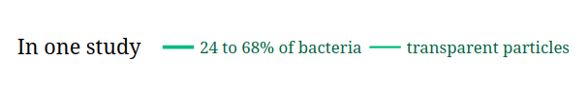
In one study, 24 to 68% of bacteria are living on transparent particles
In one study, 24 to 68% of bacteria were on transparent particles (13)
In one study, 24 to 68% of bacteria were on transparent particles
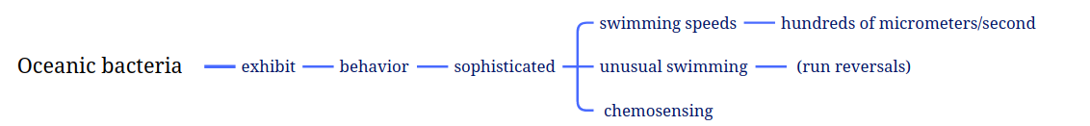
Oceanic bacteria exhibit sophisticated behavior in swimming speeds of hundreds of micrometers per second, unusual swimming (run reversals) and chemosensing.
Oceanic bacteria (14) exhibit sophisticated behavior—swimming speeds of hundreds of micrometers per second, unusual swimming (run reversals), and chemosensing.
Oceanic bacteria exhibit sophisticated behavior – swimming speeds of hundreds of micrometers per second, unusual swimming (run reversals), and chemosensing.
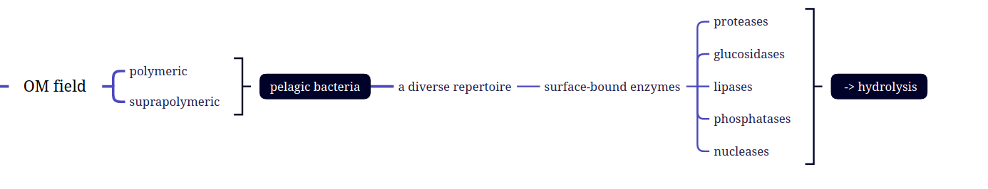
The filed of organic matter is polymeric and suprapolymeric which determines pelagic bacteria with a diverse repertoire producing surface-bound enzymes-- proteases, glucosidases, lipases, phosphatases, nucleases-- to make hydrolysis.
The organic matter field is dominantly polymeric and suprapolymeric, so most pelagic bacteria have a diverse repertoire of surface-bound enzymes (proteases, glucosidases, lipases, phosphatases, nucleases) to cause its hydrolysis (15)
The organic matter field is dominantly polymeric and suprapolymeric, so most pelagic bacteria have a diverse repertoire of surface-bound enzymes (proteases, glucosidases, lipases, phosphatases, nucleases) to cause its hydrolysis.
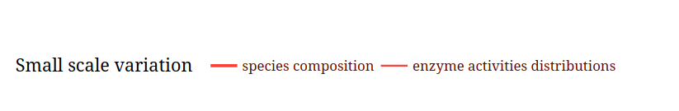
Small scale variation of species composition can significantly influence the distributions of enzyme activities.
Small-scale variation of species composition can significantly change the distributions of enzyme activities (16).
Small scale variation of species composition can significantly change the distributions of enzyme activities.
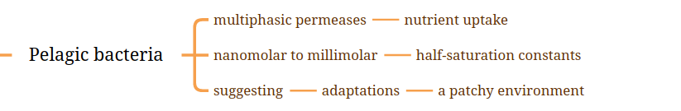
Pelagic bacteria have multiphasic permeases for nutrient uptake with nanomolar to millimolar half-satuaration constants suggesting the asaptations of a patchy environment.
Pelagic bacteria also have multiphasic permeases for nutrient uptake (17), with nanomolar to millimolar half-saturation constants, suggesting their adaptations to life in a patchy environment.
Pelagic bacteria also have multiphasic permeases for nutrient uptake, with nanomolar to millimolar half-satuaration constants, suggesting their adaptations to life in a patchy environment.
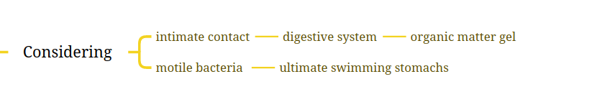
Considering intimate contact with digestive system in the organic matter gel, motile bacteria exhibit ultimate swimming stomachs.
Considering the intimate contact of their “digestive system” with the organic matter gel, motile bacteria are the “ultimate swimming stomachs” .
Considering intimate contact of their ‘digestive system’ with the organic matter gel, motile bacteria are the ultimate swimming stomachs.
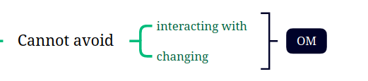
They cannot avoid interacting with and changing the organic matter.
They cannot avoid interacting with and changing organic matter.
They cannot avoid interacting with and changing organic matter.

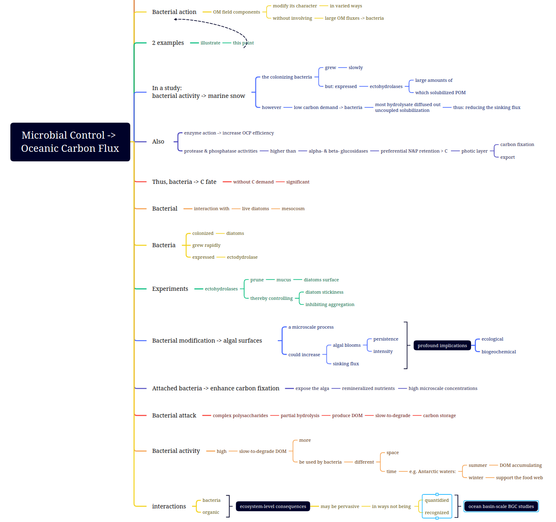
Bacterial action on components of the organic matter field can modify its character in varied ways without necessarily involving large organic matter fluxes into bacteria. Two examples illustrate this point. In a study of bacterial activity on marine snow (19), the colonizing bacteria grew slowly but expressed large amounts of ectohydrolases, which solubilized particulate organic matter; however, because of the low carbon demand of these bacteria, most hydrolysate diffused out (“uncoupled solubilization”), thus reducing the sinking flux. Also, enzyme action was thought to increase the efficiency of the oceanic carbon pump; protease and phosphatase activities were much higher than those of α- and β-glucosidases, and this would cause preferential nitrogen and phosphate retention compared with carbon in the photic layer where it supports more carbon fixation and export. Thus, bacteria influenced the fate of carbon without a significant carbon demand. Bacterial interaction with live diatoms was examined in a mesocosm (20). Bacteria colonized the diatoms, grew rapidly, and expressed large amounts of ectohydrolase. Experiments suggested that ectohydrolases of attached bacteria “prune” mucus from the surface of diatoms, thereby controlling diatom stickiness and inhibiting aggregation. Bacterial modification of algal surfaces, a microscale process, could increase the persistence and intensity of algal blooms, as well as influence the sinking flux, with profound ecological and biogeochemical implications. Attached bacteria could also expose the alga to high microscale concentrations of remineralized nutrients, thus enhancing carbon fixation. Partial hydrolysis of complex polysaccharides by bacterial attack could produce slow-to-degrade dissolved organic matter, resulting in carbon storage (high bacterial activity could actually produce more slow-to-degrade dissolved organic matter). This could be used by bacteria at a different place and time (for example, dissolved organic matter accumulating in Antarctic waters during summer could support the food web during winter). These and other examples show that the ecosystem-level consequences of bacteria-organic matter interactions may be pervasive in ways not currently being quantified, or even recognized, in ocean basin-scale biogeochemical studies.
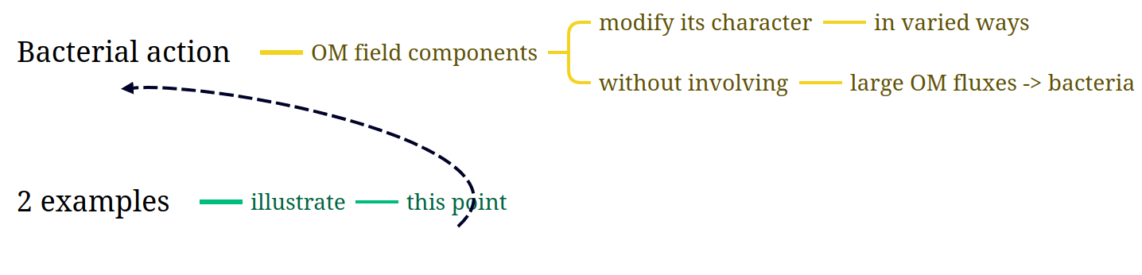
Bacterial action can act on the components of organic matter field by modifying its character in varied ways without involving large organic matter fluxes into bacteria.
2 examples can illustrate this point.
Bacterial action on components of the organic matter field can modify its character in varied ways without necessarily involving large organic matter fluxes into bacteria.
Two examples illustrate this point.
Bacterial action on components of the organic matter field can modify its character in varied ways without necessarily involving large organic matter fluxes into bacteria.
Two examples illustrate this point.
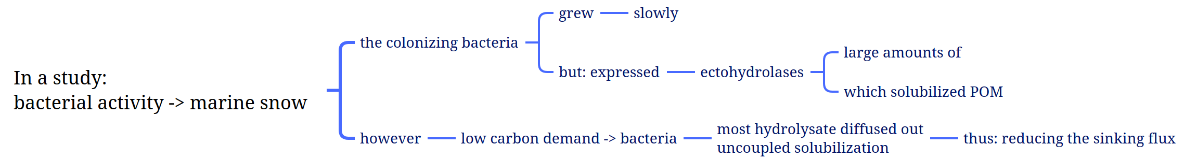
In a study of bacterial activity on marine snow, the colonizing bacteria grew slowly but expressed large amounts of ectohydrolases, which solubilized particulate organic matter.
In a study of bacterial activity on marine snow (19), the colonizing bacteria grew slowly but expressed large amounts of ectohydrolases, which solubilized particulate organic matter;
However, most hydrolysate diffused out because of low carbon demand of bacteria, uncoupled solubilization, thus reducing the sinking flux.
however, because of the low carbon demand of these bacteria, most hydrolysate diffused out (“uncoupled solubilization”), thus reducing the sinking flux.
However, because of the low carbon demand of these bacteria, most hydrolysate diffused out (‘uncoupled solubilization’), thus reducing the sinking flux.
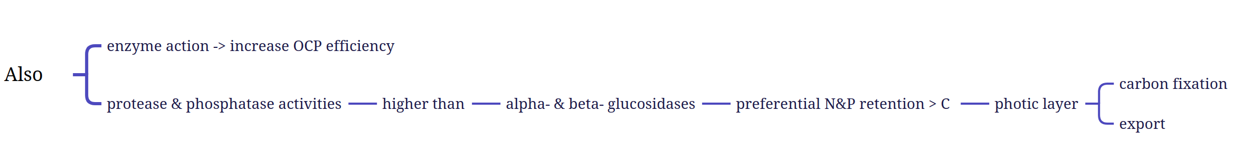
Also, enzyme action was thought to increase the efficiency of oceanic carbon pump.
Protease and phosphatase activities are higher than alpha- and beta- glucosidases which cause a preferential retention of nitrogen and phosphate than carbon in the photic layer where carbon fixation and export occurs.
Also, enzyme action was thought to increase the efficiency of the oceanic carbon pump; protease and phosphatase activities were much higher than those of α- and β-glucosidases, and this would cause preferential nitrogen and phosphate retention compared with carbon in the photic layer where it supports more carbon fixation and export.
Also, enzyme action was thought to increase the efficiency of the oceanic carbon pump.
Protease and phosphatase activities were much higher than those of alpha and beta glucosidases, and this would cause preferential retention of nitrogen and phosphate compared with carbon in the photic layer where it supports more carbon fixation and export.
Also, enzyme action was thought to increase the efficiency of the oceanic carbon pump.
Protease and phosphatase activities were much higher than those of alpha and beta glucosidases, and this would cause preferential nitrogen and phosphate retention compared with carbon in the photic layer where it supports more carbon fixation and export.
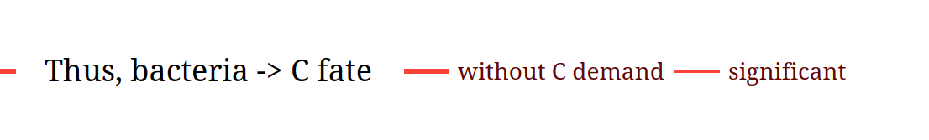
Thus, bacteria can influence the carbon fate without significant carbon demand.
Thus, bacteria influenced the fate of carbon without a significant carbon demand.
Thus, bacteria influenced the fate of carbon without a significant carbon demand.
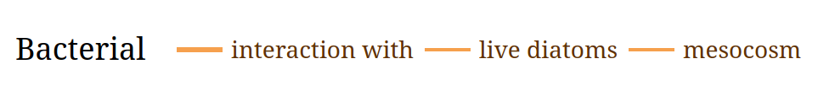
Bacterial interaction with live diatoms at a scale of mesocosm.
Bacterial interaction with live diatoms was examined in a mesocosm
Bacterial interaction with live diatoms was examined in a mesocosm.
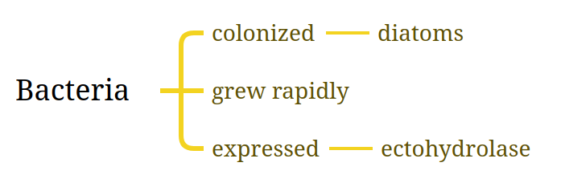
Bacteria colonized diatoms, grew rapidly and expressed ectohydrolase.
Bacteria colonized the diatoms, grew rapidly, and expressed large amounts of ectohydrolase.
Bacteria colonized the diatoms, grew rapidly and expressd large amounts of ectohydrolase.
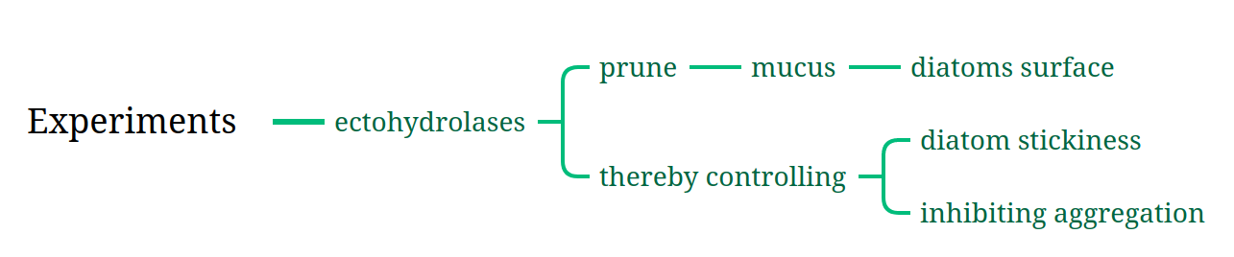
Experiments on ectohydrolases indicated that they can prune mucus from the surface of diatoms, thereby controlling diatom stickiness and inhibiting aggregation.
Experiments suggested that ectohydrolases of attached bacteria “prune” mucus from the surface of diatoms, thereby controlling diatom stickiness and inhibiting aggregation.
Experiments suggested that ectohydrolases of attached bacteria prune mucus from the surface of diatoms thereby controlling diatom stickiness and inhibiting aggregation.
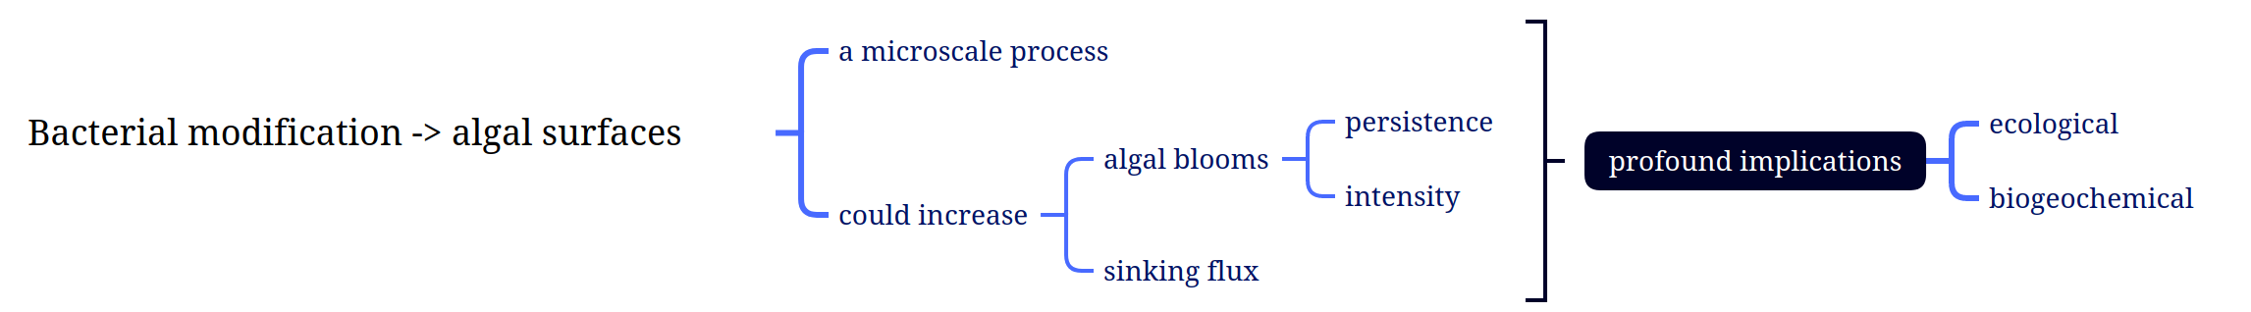
Bacterial modification of algal surfaces is a microscale process, this could increase persistence and intensity of algal blooms thus increase sinking flux with profound ecological and biogeochemical implications.
Bacterial modification of algal surfaces, a microscale process, could increase the persistence and intensity of algal blooms, as well as influence the sinking flux, with profound ecological and biogeochemical implications.
Bacterial modification of algal surfaces, a microscale process, could increase persistence and intensity of algal blooms as well as influence the sinking flux with profound ecological and biogeochemical implications.
Attached bacteria enhance carbon fixation by exposing the alga to high microscale concentrations of remineralized nutrients.
Attached bacteria could also expose the alga to high microscale concentrations of remineralized nutrients, thus enhancing carbon fixation.
Attached bacteria could also expose the alga to high microscale concentrations of remineralized nutrients thus enhancing carbon fixation.
Partial hydrolysis of complex polysaccharides by bacterial attach produce slow-to-degrade dissolved organic matter and change the carbon storage.
Partial hydrolysis of complex polysaccharides by bacterial attack could produce slow-to-degrade dissolved organic matter, resulting in carbon storage
Partial hydrolysis of complex polysaccharides by bacterial attack could produce slow-to-degrade dissolved organic matter resulting in carbon storage.
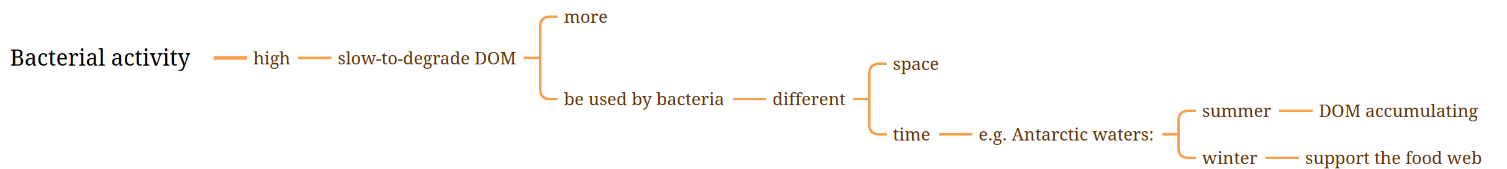
High bacterial activity produces more slow-to-degrade dissolved organic matter which could be used by bacteria in different time and space. For example, dissolved organic matter accumulating in Antarctic waters during summer can support the food web during winter.
(high bacterial activity could actually produce more slow-to-degrade dissolved organic matter). This could be used by bacteria at a different place and time (for example, dissolved organic matter accumulating in Antarctic waters during summer could support the food web during winter).
High bacterial activity could actually produce more slow-to-degrade dissolved organic matter, this could be used by bacteria at a different space and time, for example, dissolved organic matter accumulating in Antarctic waters during summer could support the food web during winter.

The ecosystem-level consequences of bacteria-organic matter interactions may be pervasive in ways not being quantified and even recognized by biogeochemical studies at ocean basin-scale.
These and other examples show that the ecosystem-level consequences of bacteria-organic matter interactions may be pervasive in ways not currently being quantified, or even recognized, in ocean basin-scale biogeochemical studies
These and other examples show that the ecosystem-level consequences of bacteria-organic matter interactions may be pervasive in ways not currently being quantified or even recognized, in ocean basin-scale biogeochemical studies.

